**Project Report Template**

**1 INTRODUCTION**

1.1 Overview

India is the world's third-largest producer and third-largest consumer of electricity.

The national electric grid in India has an installed capacity of 370.106 GW as of 31 March2020. Renewable power plants, which also include large hydroelectric plants, constitute35.86% of India's total installed capacity. During the fiscal year (FY) 2019–20, the total electricity generation in the country was 1,598 TWh, of which 1,383.5 TWh generated by utilities. The gross electricity consumption per capita in FY2019 was 1,208 kWh.

In 2015-16, electric energy consumption in agriculture was recorded as being the highest (17.89%) worldwide. The per capita electricity consumption is low compared to most other countries despite India having a low electricity tariff. In light of the recent COVID-19 situation, when everyone has been under lockdown for the months of March to June the impacts of the lockdown on economic activities have been faced by every sector in a positive or a negative way.

The dataset is exhaustive in its demonstration of energy consumption state wise. Analyzing Electricity Consumption in India from Jan 2019 till 5th December 2020. This dataset contains a record of Electricity consumption in each states of India, here we are going to analyze State wise, Region wise and Overall Electricity consumption in India.

1.2 Purpose

We are analyzing electricity consumption in India during the period from Jan 2019 till 5th December 2020. We see that the electricity consumption during the covid lockdown was low compared to period before covid. Using this consumption patterns and trends, the analysis can help businesses identity market opportunities and develop strategies to meet the growing demand for electricity in India. Electricity demand dropped quickly across India during lockdown which we can see and compare in the project.

**2 Problem Definition & Design Thinking**

2.1 Empathy Map

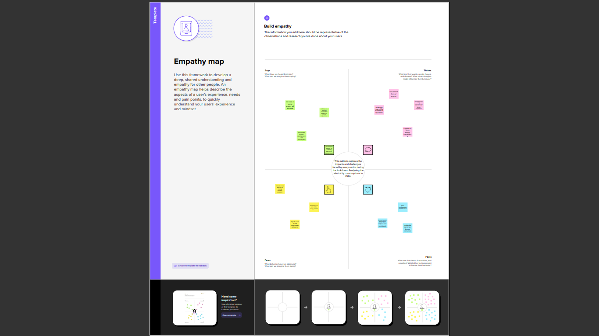

2.2 Ideation & Brainstorming Map

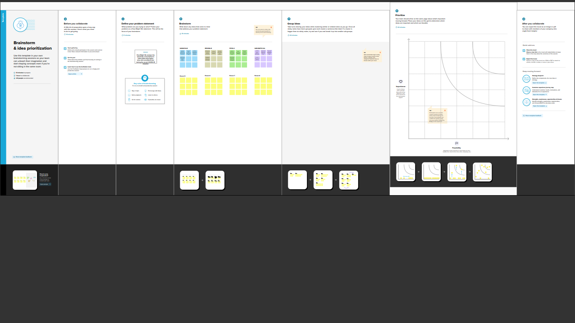

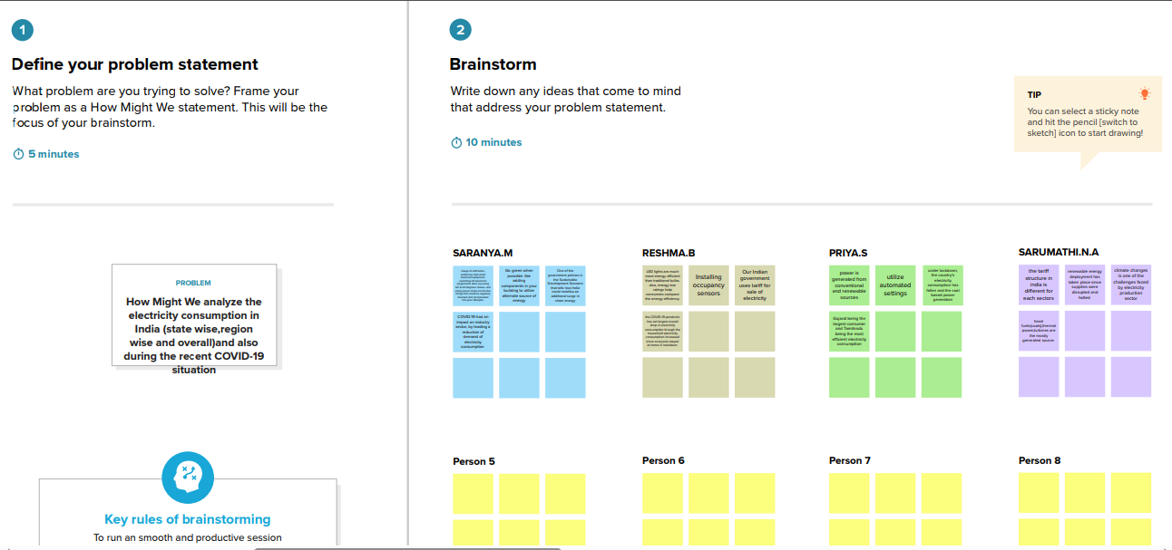

**3 RESULT**

3.1 Dashboard and Story Screenshots

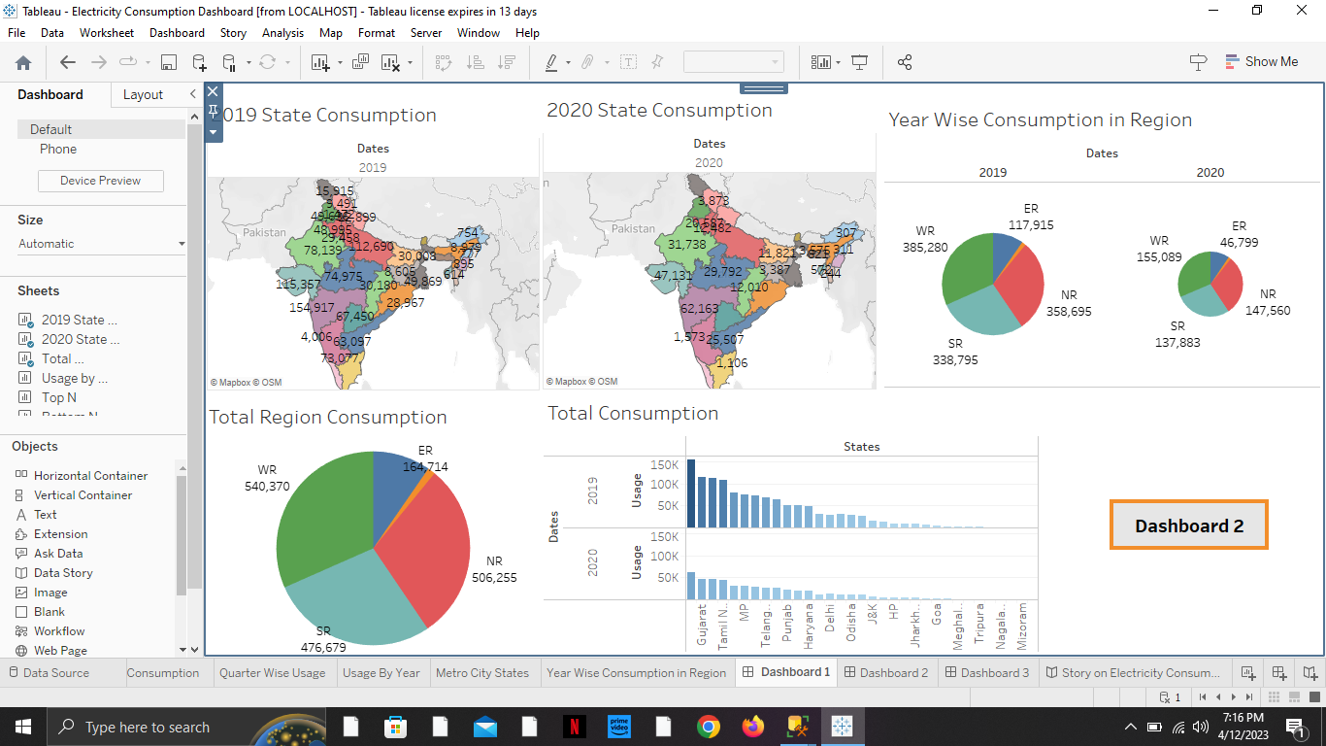

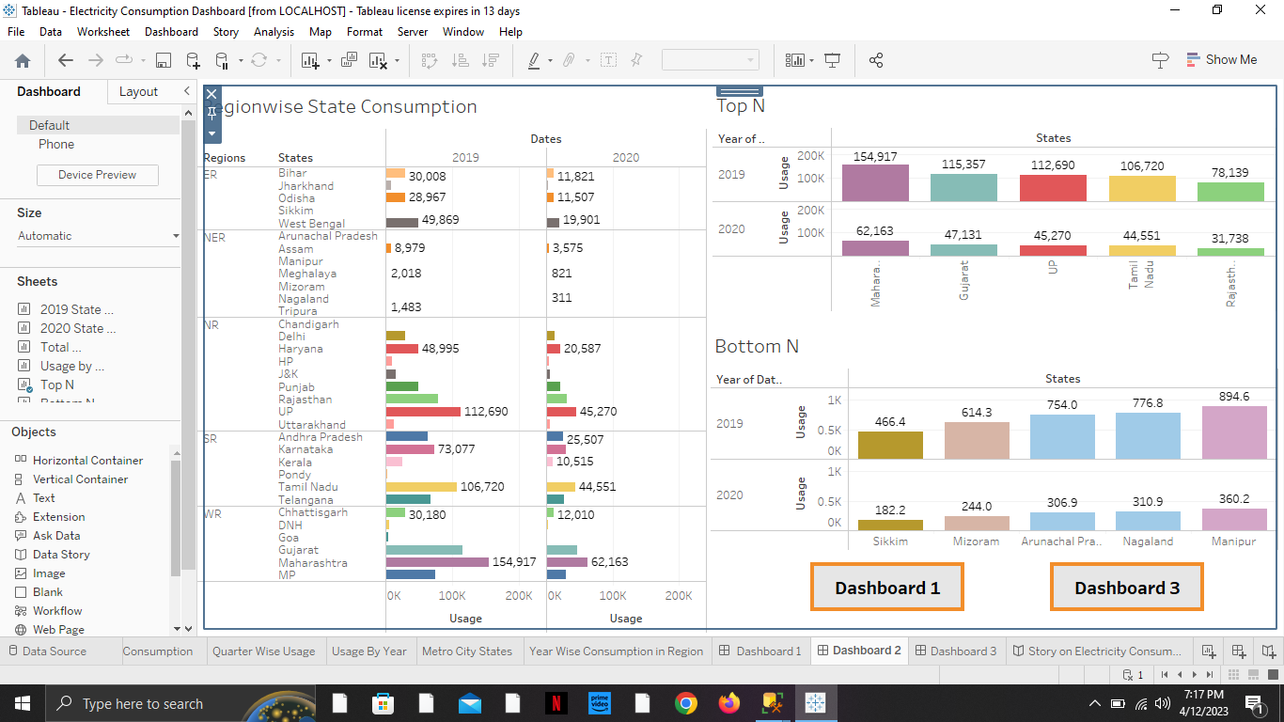

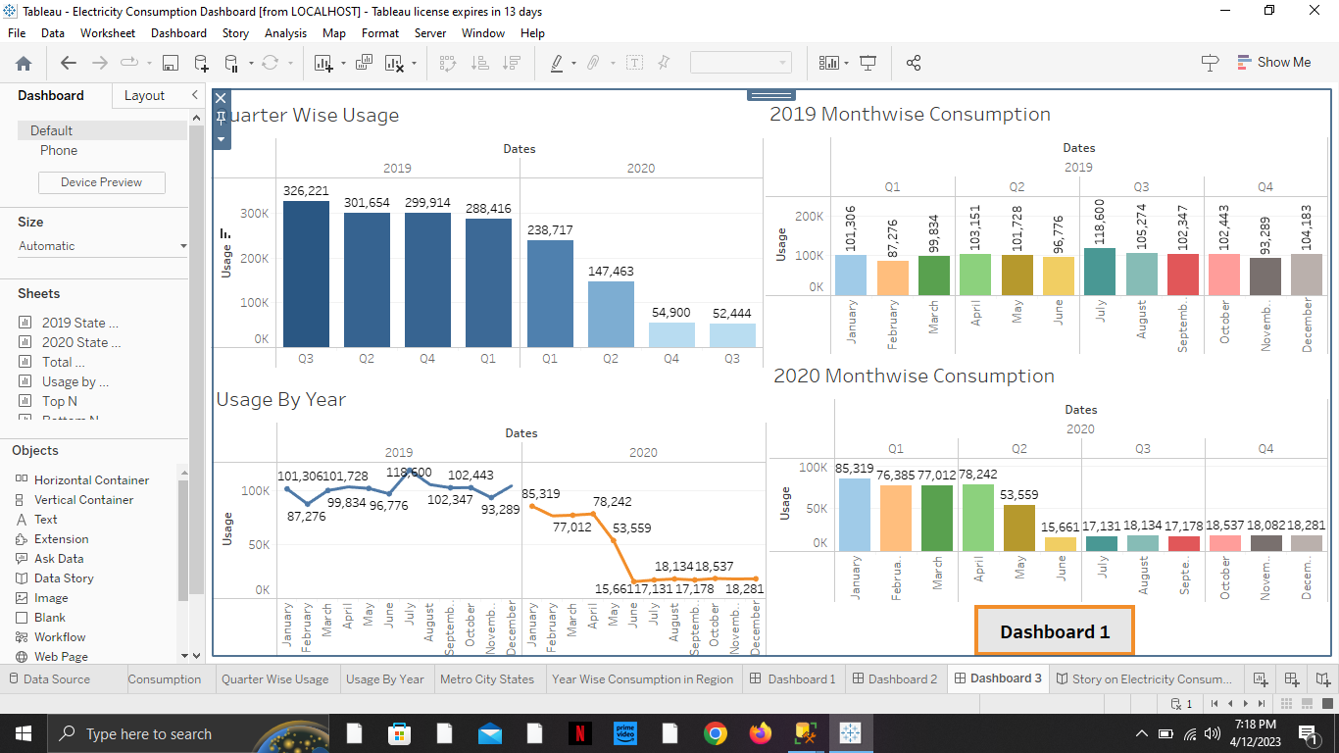

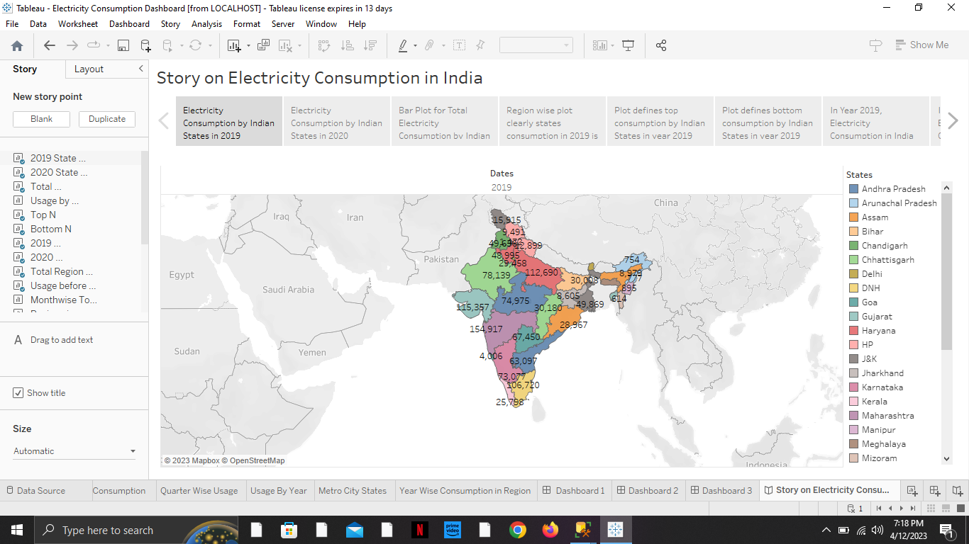

3.2 Web Application Screenshots

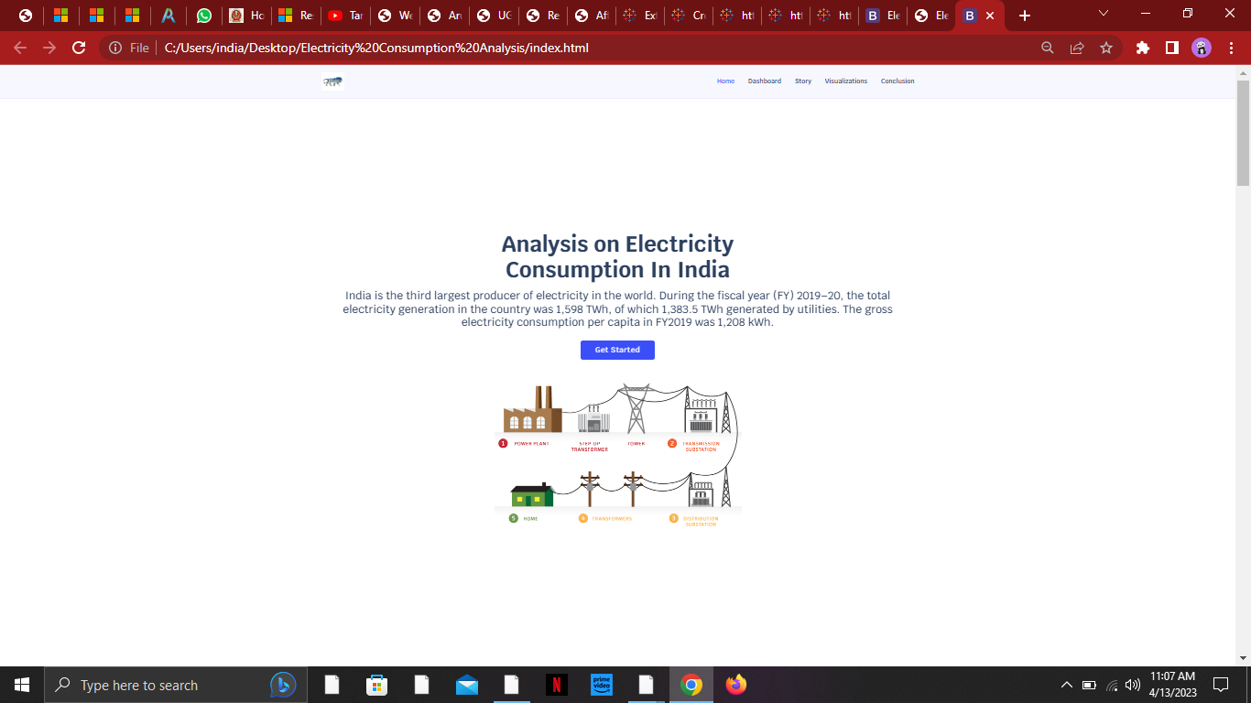

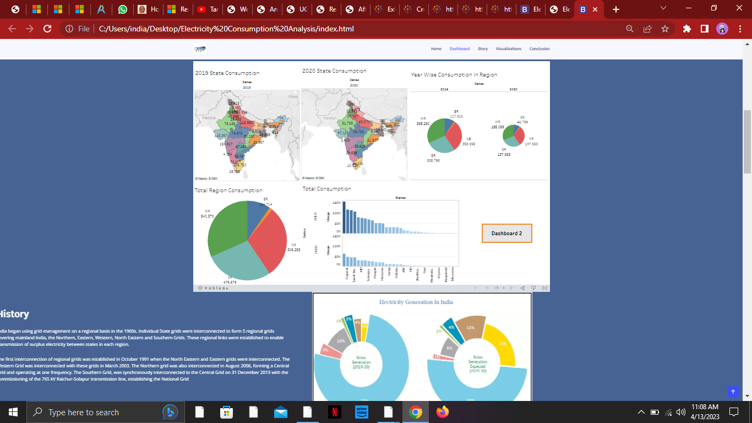

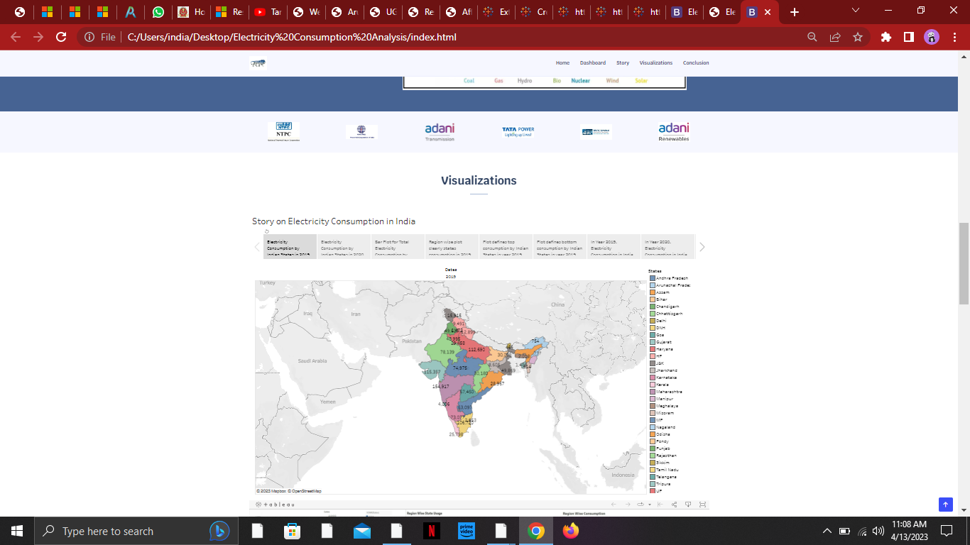

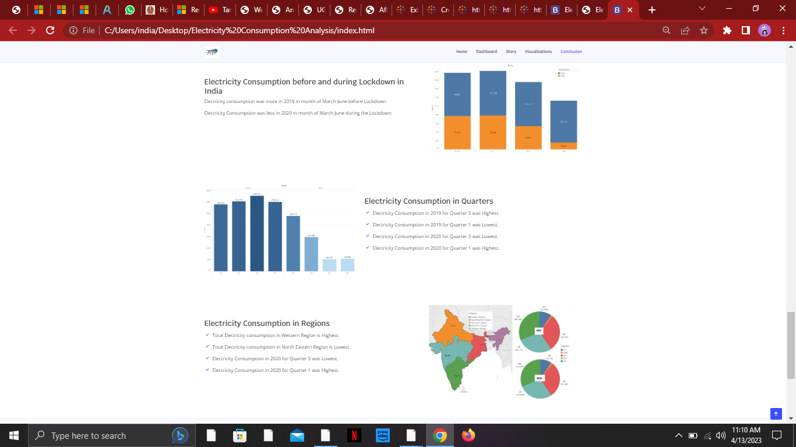

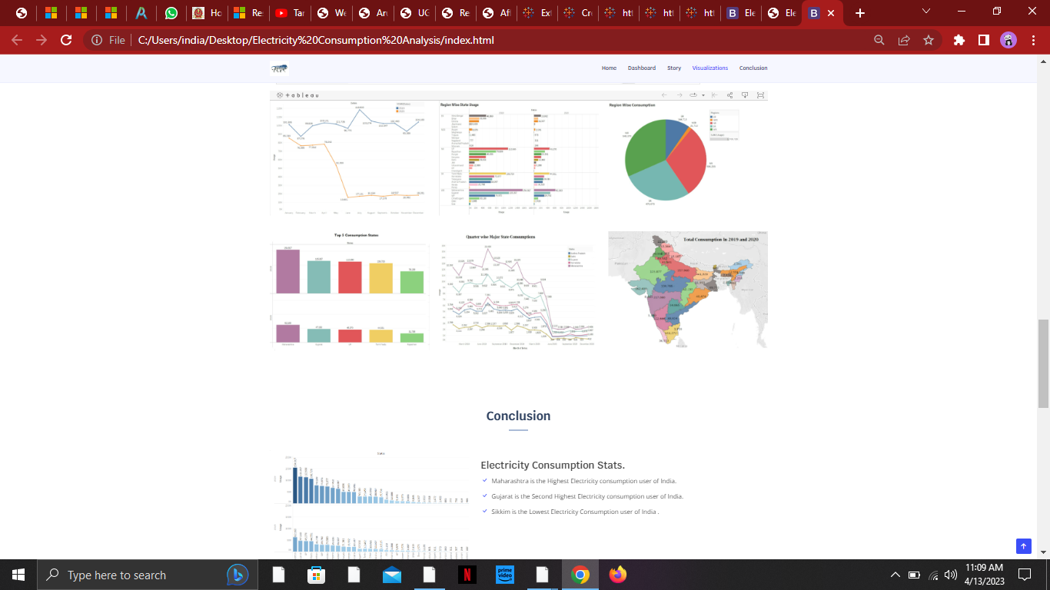

**4 ADVANTAGES & DISADVANTAGES**

During the lockdown period, the industry sector had less electricity consumption. Due to which the productivity rate was low and the demand in people got increased. It was a great disadvantage that the product rate was higher than usual. Another disadvantage is the usage of electricity in households were little higher because people stayed mostly in home (separate rooms).

In lockdown the most electricity used sectors is the hospitals. Since the covid got spread more, we saw that the patients got more and the electricity was used widely for treatment.

In this project it is advantageous to know the consumption patterns before and after lockdown. We can analyze its usage and make use of it for future references.

**5 APPLICATIONS**

This solution can be applied in media field to create an awareness and content to the people that how the country used the electricity during the given period. We can use this solution to know which state and region consumed less electricity and create new policies promoting energy efficiency and energy development. This analysis can help businesses identify marketing strategies. This information can be used to identify areas where consumption is high and areas where it is low. Identify opportunities for improving energy efficiency and reducing consumption in different sectors and regions.

**6 CONCLUSIONS**

Here we analyzed the State wise, Region wise and Overall Electricity consumption in India and compared it using the visualizations. We made the dashboards and story using the number of visualizations we created in tableau. Then we published it in the tableau public.

**7 FUTURE SCOPE**

Enhancements that can be made in the future are : we use visualizations for different sectors and their usage in covid separately, we can make further development to find how to use electricity if another covid wave hits or in situations when some pandemic happens again.

**8 APPENDIX**

1. Source Code

<file:///C:/Users/india/Desktop/Electricity%20Consumption%20Analysis/index.html>

1. MS SQL Commands

